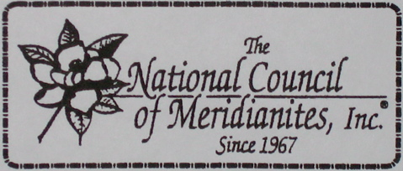

The 56th National Council of Meridianites, Inc. Convention
Cincinnati, OH
June 25-28, 2026

Greetings,

We are excited to announce that the National Council of Meridianites, Inc., (NCM) will host its 56th Convention in the Queen City of Cincinnati, Ohio, June 25-26, 2026. We are looking forward to returning to this city which serves as home to several residents from Meridian, MS. Our presence in Cincinnati will contribute to the local economy in several ways. We will occupy space in local hotels, increase business in restaurants, malls, shopping centers and local boutiques, utilize public and private transportation, and visit local tour sights and museums.

The National Council of Meridianites, Inc., is a 501(c)(3), that was created over five decades ago to serve as a social and business organization to bring together former residents of Meridian, MS, their family members and friends, to reconnect, socialize, and form new relationships. In addition to the social activities, we also conduct business meetings and provide college scholarships to high school graduates to support them during their freshmen year of college.

We would like to provide businesses, organizations, and individuals with an opportunity to contribute to our convention. There are several ways to help us make our convention in the Queen City a success; by donating to the following:
- Sponsorship (by making a cash donation to NCM)
- Roots Scholarship Fund
- NCM/JSC Scholarship Foundation
- In-kind Contributions (for example, food & beverage donations, to our picnic and/or hospitality suite)
- In-kind contributions (for example, alcohol beverages to the hospitality suite)
All cash donations are tax exempt. All donations will be recognized by being included in our printed materials such as posters, souvenir journals, agendas, etc.
All cash donations should be made payable to:
The National Council of Meridianites, Inc. and mailed to our National Treasurer, Angela Smith
1702 Creekside Drive
Katy, TX 77493
Phone: 281-989-5052

Credit card donations can be made on our website:
https://www.nationalcouncilofmeridianites.com

For all in-kind donations, please contact either of the following members:
Denita Dean, National President (ph. 202-689-5774 or Denita007@icloud.com)
Calisa Tubbs, Cincinnati (ph. 513-728-5359 or calisatubbs@yahoo.com)
Carise Tubbs, Cincinnati (ph. 513-693-0708 or Carisetubbs22@gmail.com)

We sincerely appreciate all donations, and we are looking forward to celebrating with you in the Queen City of Cincinnati, Ohio.

Sincere Appreciation,

Denita Dean, MPH
National President, NCM

